

WEEK IN REVIEW

October 29-November 2, 2018

**ACCOMPLISHMENTS:**

**Task #1:** Our football team won their final game against Cathedral City. We are super proud of our boys!

**Task #2:** Dia De Los Muertos took place on Thursday evening. The best decorated pod award went to Mrs. Murillo’s classes. It was a huge success!

**Task #3:** Our Drama class performed a series of short plays on bullying during school on Thursday for students and on Friday evening for family members.

**Task #4:** We had our Academic Awards Ceremony on Tuesday evening for students who had a 3.5 or better last year and for those students who reclassified. Students received a letter or patch to commemorate the occasion.

**Task #5:** Red Ribbon Week Blood Drive and lunch activities throughout the week.

**Task #6:** Our Aviation and Film Pathways got together to create a video of all of the sidewalk art created for our Dias De Los Muertos Celebration by Ms. Cutchin’s & Ms. Graham’s Art students. Watch the film on our website. <https://youtu.be/3on-v3aeVHM>

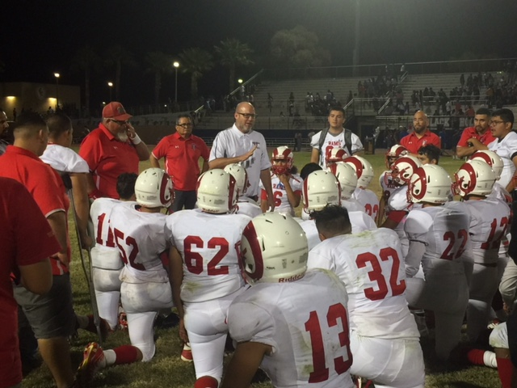 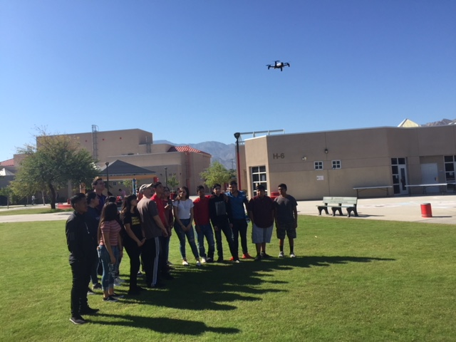 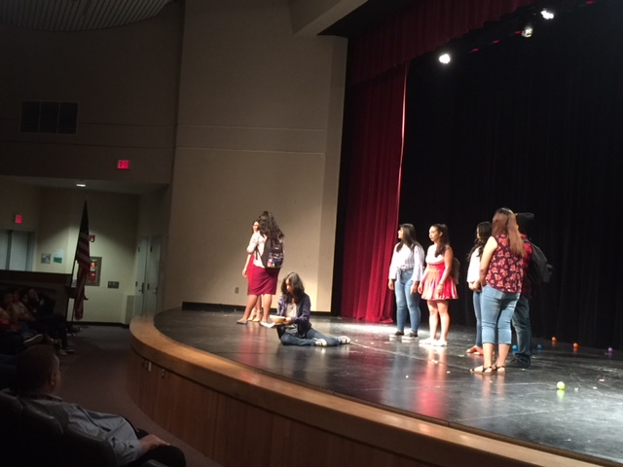 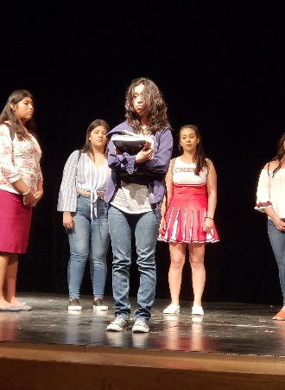

Football Final Game First Drone CTE & Aviation Bully Play CTE Drama

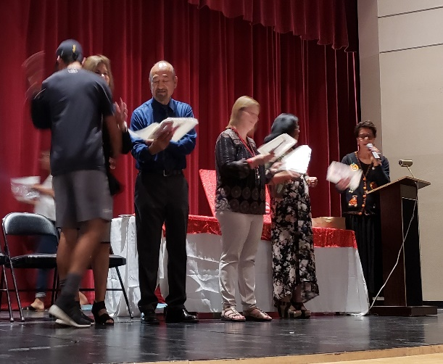 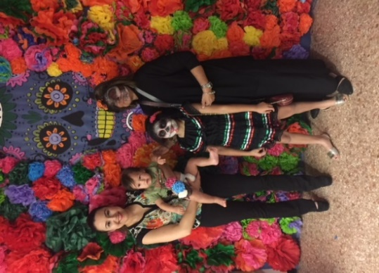 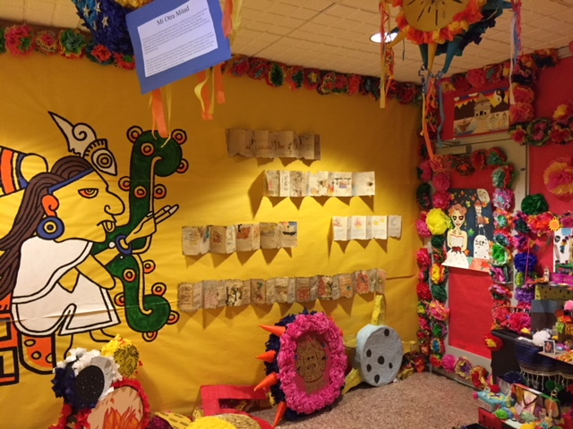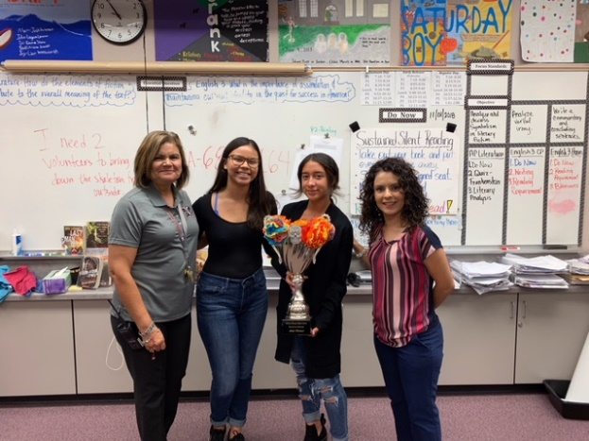

Academic Awards Dia De Los Muertos Winning Pod by Mrs. Murillo’s class