

WEEK IN REVIEW

November 12-16, 2018

**ACCOMPLISHMENTS:**

**Task #1:** On Saturday, November 3, 2018 two of our DM migrant students received a Certification of Recognition at the **4th Annual Migrant Parent Leadership Conference**. 12th grade migrant student, Alicia Hernandez and 11th grade migrant student Alejandro Palomares were recognized for their hard work and dedication.

**Task #2:** MS Tafoya & Ms. Murillo took 50 students to participate in the UCR AP Readiness Program at University of California Riverside on Saturday.

**Task #3:** Coffee with the Principal took place on Tuesday night.

**Task #4:** Our CTE Dance group partnered with the McCallum Theater for the East Valley Dance Project. This is our 12th year of performing alongside professional dancers at the McCallum Theater on Sunday. Beautiful job!

**Task #5:** The Varsity Football Banquet was held at Palm Valley Country Club Tuesday evening.

**Task #6:** DM Ethnic Studies Team demoed and debriefed lessons alongside CVHS and West Shores High School Teachers.

Teachers recognized for students scoring in the top 10% in the District on CAASPP

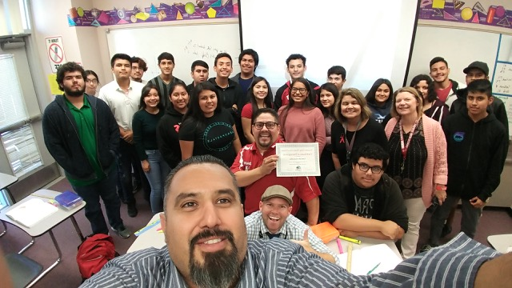 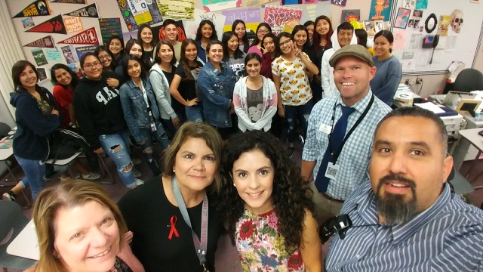 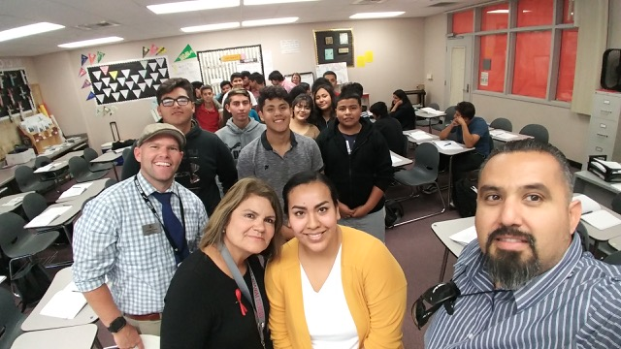

Mr. Gonzalez(Math) Mrs. Murrillo(English) Ms. Cumplido(English)

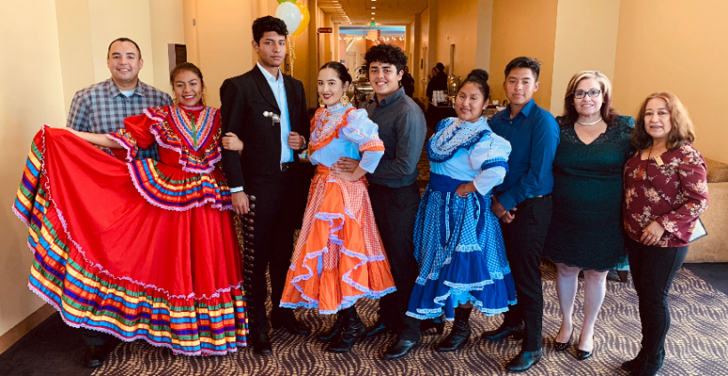 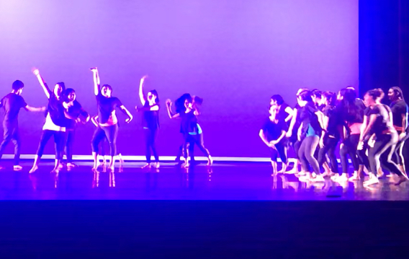 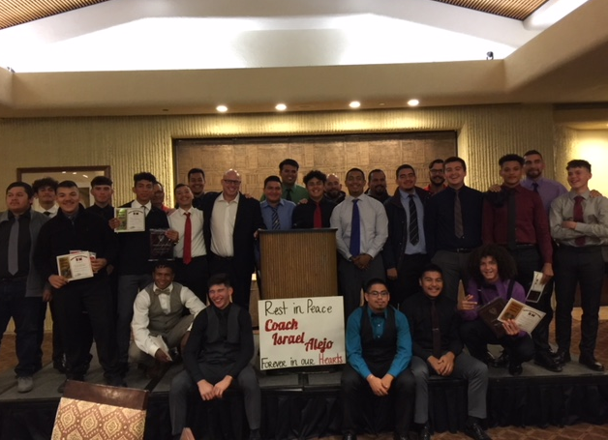

Migrant Parent Leadership Conference East Valley Dance Project Varsity Football Banquet

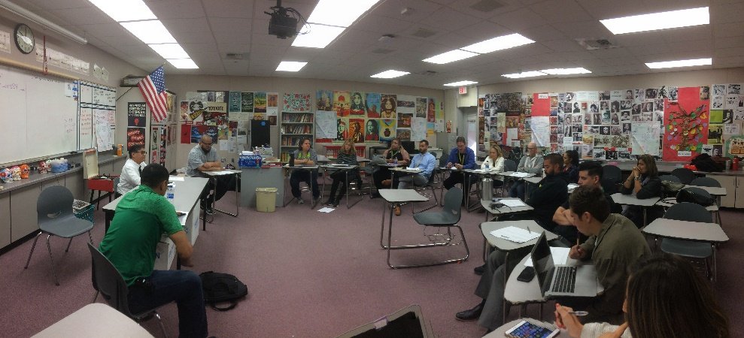 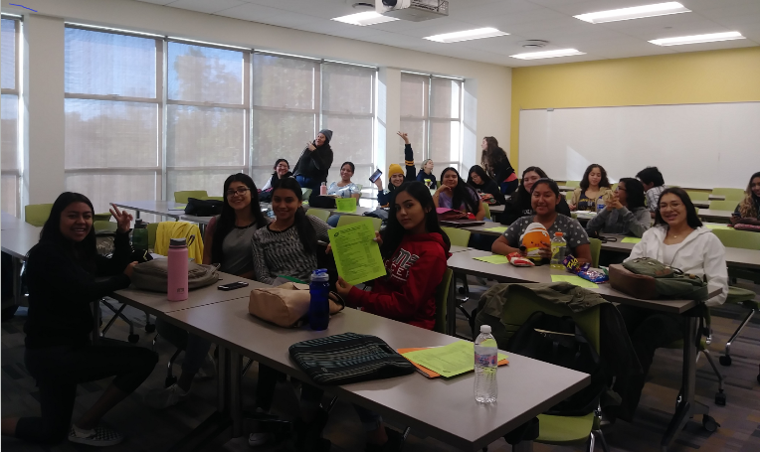

Ethnic Studies Demo Debrief UCR AP Readiness Program